================================= Other IMP topic In Spring boot =====================

App_Properties Topic :

Normal ga Spring boot lo yedanna msg or properties or any configuration related vi direct ga Program Lo Hard code cheyakunda vatini properties file nuodi load chesukuntamu

Previous ga load chese Example

application.properties
app.message=Application started successfully

JAVA Code

@Value("${app.message}")
private String message;

But eppudu point : Eila chala msg or configuratio realted vi vunte anni eilane rayatam recommend kadu So daniki App_Properties Topic ni use chesthamu

Diagram Explanation : required tag ni application.yml file lo rastham vatini oka JAVA class loki lode chesukoni manaki kavalsina chota a JAVA class ni vadi a tags ni use chesthamu

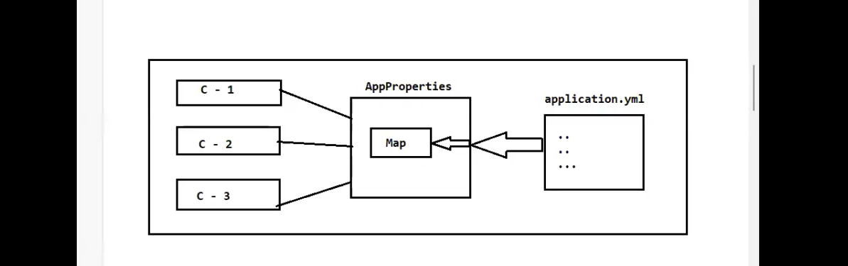

application.yml
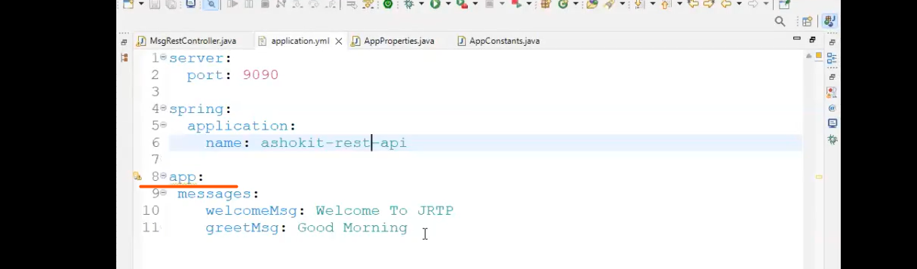

Custom JAVA Class : to Load the tags

IMP Points : yml file ye name avithe echhamo ade name tho e class lo variable create cheyali and prefix ni kuda set cheyali

Why we are using Map --> because Map will store values in key,value pair
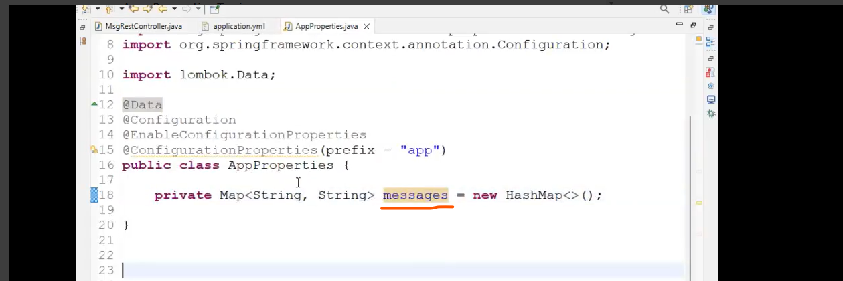

Controller class : Key point yml file tag ki echhina msg String lo key ga pass chesthe manaki kavlsina msg ni use chesukovachhu
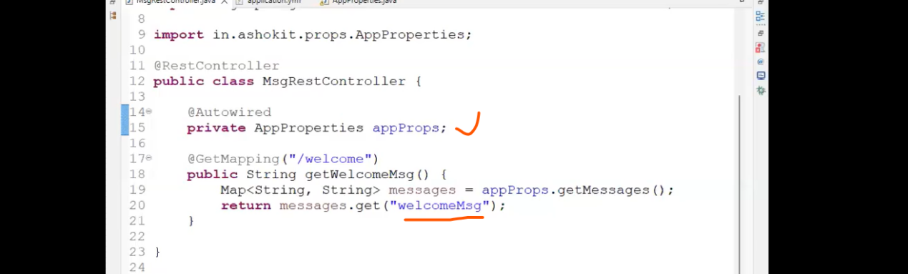

String APP_Constants class : Spring boot lo Strings ni direct ga rayatam not recommended avi msgs avina yml key tgs avina sare
So dani kosam APP_Constants class ni use chesi a strings oka variable ni difine chesi vatini code lo use chesukovachhu

APP_Constants class : above Example lo controller class lo direct ga rasina ymal string name ni e class lo rasi vatini use chesukuntamu
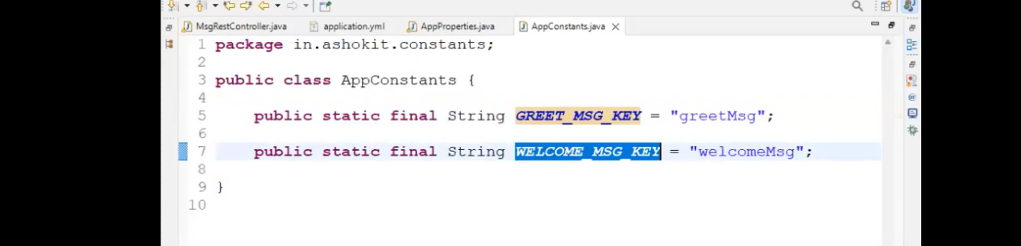

Updated Controller class : yml tags ni APP_Constants class dwara use cheyatam



